**Bob’s Week**

Name: _

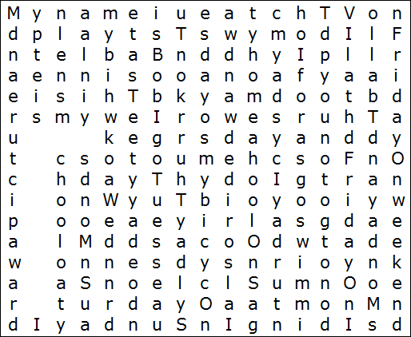Όλο το κείμενο βρίσκεται μέσα στο λευκό πλαίσιο. Μπορείτε να το σημειώσετε με το μολύβι σας;

My name is Bob. I go to school on Monday, Tuesday, Wednesday, Thursday and Friday.

On Monday and Thursday, I play football. I do my homework on Tuesday and watch TV on Friday. On weekends, I do not go to school.

On Saturday, I go swimming. I also ride my bicycle on Saturday. On Sunday, I draw a picture and play table tennis. This is my week.

Συμπληρώστε τι κάνει ο Bob κάθε μέρα της εβδομάδας.

|  |  |  |
| --- | --- | --- |
| Days | What does Bob do? | What does Bob do? |
| 1. Monday | **he goes to school** | **he plays football** |
| 2. Tuesday |  |  |
| 3. Wednesday |  |  |
| 4. Thursday |  |  |
| 5. Friday |  |  |
| 6. Saturday |  |  |
| 7. Sunday |  |  |

© [www.kizschool.com](http://www.kizschool.com/)